**Exploration Using Augmented and Virtual Reality**

Submitted in partial fulfilment of the requirements

of the degree of

Bachelor of Engineering

by

**Vaibhav Goyal (19)**

**Radhika Raghuwanshi (54)**

**Rohini Yedelli (77)**



under the guidance of

Supervisor:

**Mrs Smita Jangale**

Department of Information Technology

Vivekanand Education Society’s Institute of Technology

2017-18

**Vivekanand Education Society’s**

**Institute of Technology**

**(Affiliated to University of Mumbai, Approved by AICTE & Recognized by Govt. of Maharashtra)**

**Department of Information Technology**

**CERTIFICATE**

This is to certify that **Mr Vaibhav Goyal, Ms Radhika Raghuwanshi and Ms Rohini Yedelli** of Fourth Year Information Technology studying under the University of Mumbai have satisfactorily presented the project entitled **Exploration Using Augmented and Virtual Reality** as a part of the PROJECT-I for Semester-VII under the guidance of **Mrs Smita Jangale**  in the year 2017-2018.

Date: 31/10/2017

Mrs Shalu Chopra Mrs Smita Jangale

Head of Department Supervisor/Guide

**Vivekanand Education Society’s**

**Institute of Technology**

**(Affiliated to University of Mumbai, Approved by AICTE & Recognized by Govt. of Maharashtra)**

**Abstract**

In this advanced era of technology, people believe what they see and experience through their eyes. Virtual Reality is a computer simulated reality which replicates a real environment, and simulate a user's physical presence in this environment while Augmented Reality blurs the line between what's real and what's computer-generated by enhancing what we see, hear and feel. This alone showcases the potential of Virtual and Augmented Reality in fields of gaming, e-commerce, tourism, education etc. to provide real life experiences.

The proposed android application “Exploration” will be a perfect blend of virtual and augmented reality. “Exploration” will have various functionalities like providing 3D view of different tourist places objects around you in the real world and also help students to view 3D complex structure in real world which would be difficult to imagine. The main aim of “Exploration” would be to provide a more immersive and interactive real environment to everyone.

**Keywords:** Augmented Reality , Virtual Reality , Target , Recognition based AR , Virtual Environment, Marker, Vuforia, Unity.

Table of Contents

**1. Introduction 5**

1.1 Introduction to Virtual and Augmented Reality 5

1.2 Problem Statement 6

1.3 Objective 6

**2. Literature Survey 7**

**3. Requirements and Analysis 13**

3.1. Functional and Nonfunctional Requirements 13

3.2. Constraints 14

3.3. Hardware and Software Requirements 14

3.4. Analysis 14

4.1. Architecture 16

4.2. Detailed Design 17

4.2.1 System Design 17

4.2.2 Flow Chart 17

4.2.3 State Transition Diagram 18

**5. Expected Results and Conclusion 19**

5.1. Expected Results 19

5.2. Conclusion 20

References 21

Acknowledgment 22

# 

# **1. Introduction**

## **1.1 Introduction to Virtual and Augmented Reality**

Virtual Reality is a computer simulated reality which replicates a real environment, and simulate a user's physical presence in this environment while Augmented Reality blurs the line between what's real and what's computer-generated by enhancing what we see, hear and feel. Augmented Reality (AR) is a variation of Virtual Environments (VE), or Virtual Reality (VR) as it is more commonly called. VR technologies completely immerse a user inside a synthetic environment. While immersed, the user cannot see the real world around him. In contrast, AR allows the user to see the real world, with virtual objects superimposed upon or composited with the real world. Therefore, AR supplements reality, rather than completely replacing it.

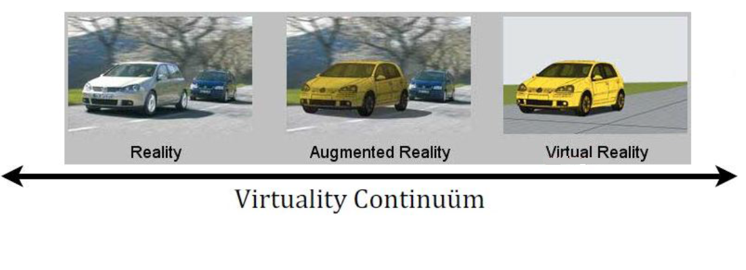

## **1.2 Problem Statement**

The traditional methods of experiencing the real world are becoming outdated day by day. With rapidly changing technology, people don't want to just see the world but also interact with it. They want to have first hand experience in learning which is possible through virtual and augmented reality.For both AR and VR, the benefits over traditional approaches are much more than just better retention and a deeper understanding. Because the technology is also interactive, the technology can be used to test and evaluate understanding and reward users who master concepts before moving on. By integrating testing into the environment itself, the content can be highly tuned and even customised based on the learning style, background or even by how fast the student is learning. The proposed android application “Exploration” will have various functionalities like providing 3d view of different tourist places objects around you in

the real world and also help students to view 3d complex structure in real world which would be difficult to imagine.

## **1.3 Objective**

The objective of the proposed project is to provide a more immersive and interactive environment to the user to learn about different things. The projected virtual objects display details that are difficult to imagine by the user. The information conveyed by the virtual objects helps a user perform real-world tasks. “Exploration” will help to inculcate learning and provide amazing experience to kids as well as adults. It will provide them a whole new look towards virtual world using Virtual and Augmented Reality.

# **2. Literature Survey**

**2.1 Literature**

Augmented Reality is the seamless fusion of the real world with generated virtual artefacts superimposed onto our view through the device. Virtual Reality (VR) technologies completely immerse a user inside a synthetic environment. While immersed, the user cannot see the real world around him. Virtual environment needs Head Mounted devices to be seen , while Augmented Reality can be seen in the real world using the application it is built on .

**History**

* In 1968, Ivan Sutherland developed the first head-mounted display system.
* In 1974, Myron Krueger built an ‘artificial reality laboratory called the video place which combined projectors with video cameras that emitted onscreen silhouettes, surrounding user in an interactive environment.
* In 1990, Boeing Researcher Tom Caudell coined the term “Augmented Reality”.
* In 1994, Julie Martin the first augmented reality Theater production, “Dancing in Cyberspace”, featuring acrobats who danced within and around virtual objects on their physical stage.
* In 1999, Naval researchers begin working on Battlefield Augmented Reality System[BARS], the robust, original model of early wearable units for soldiers.
* In 2009, print media “Esquire Magazine” tried out AR, in which it prompted readers to scan the cover to make Robert Downey Jr. come alive

**Components of Augmented Reality**

Augmented reality systems are built upon on three major buildings blocks:

1. Tracking and Registration

Tracking and Registration is needed to know the user’s exact location in comparison to his surroundings and also is used for tracking the exact eye and head movements of the user. This is the most complex part of the Augmented Reality technology as three major functions such as tracking the overall location, movement of the user’s head and eye and adjusting the graphics to be displayed are done with utmost precaution.

1. Display technology

Types of displays are used in AR technology

* Head Mounted Displays [HMD]

HMD keeps both the images of the real physical world and the virtual graphical world over the user’s world view.

* Handheld Displays

Such displays are small in size and will easily fit in one hand. These devices use video transparent techniques to relate the virtual world to the real world.Since they are easily portable and due to the bulk use of camera phones, they are used widely.

1. Real time rendering

Real time rendering means as the orientation of the target object changes in the real world, the orientation of the projected 3d object should also change simultaneously without any flickering.

**Types of Augmented Reality**

* Projection Based AR *-*

Projection based augmented reality works by projecting artificial light onto real world surfaces. Projection based augmented reality applications allow for human interaction by sending light onto a real world surface and then sensing the human interaction (i.e. touch) of that projected light. Detecting the user’s interaction is done by differentiating between an expected (or known) projection and the altered projection (caused by the user's interaction). Another interesting application of projection based augmented reality utilizes laser plasma technology to project a three-dimensional (3D) interactive hologram into mid-air.

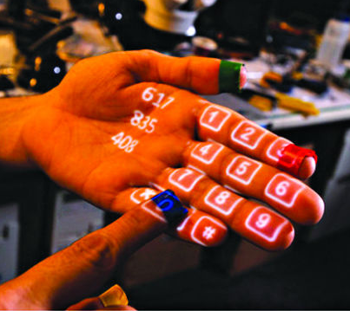

* Recognition Based AR -

Recognition based AR focuses on recognition of objects and then provide us more information about the object. e.g. when using your mobile phone to scan a barcode or QR code, you actually use object recognition technology. Fact is, except location based AR systems, all other types do use some type of recognition system to detect the type of object over which augmentation has to be done.Recognition based AR technology has varied uses as well. One of them is to detect the object in front of the camera and provide information about the object on screen. This is something similar to the AR apps for travellers (location browsers). However, the difference lies in the fact that the AR location browsers usually do not know about the objects that they see while recognition based AR apps do.

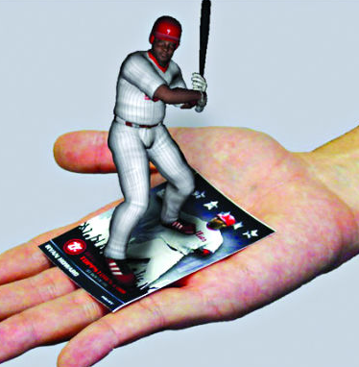

* Location Based AR -

As one of the most widely implemented applications of augmented reality, markerless (also called location-based, position-based, or GPS) augmented reality, uses a GPS, digital compass, velocity meter, or accelerometer which is embedded in the device to provide data based on your location. A strong force behind markerless augmented reality technology is the wide availability of smartphones and location detection features they provide. It is most commonly used for mapping directions, finding nearby businesses, and other location-centric mobile applications.

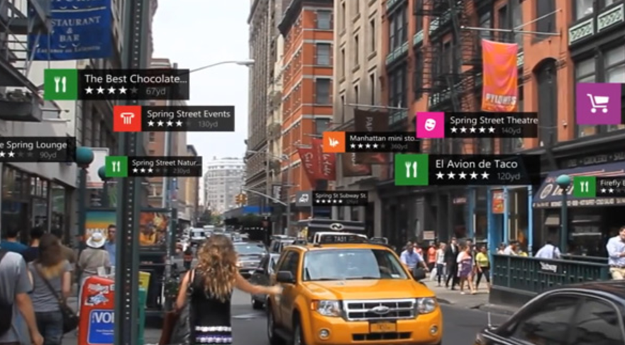

* Superimposition Based AR -

Superimposition based augmented reality either partially or fully replaces the original view of an object with a newly augmented view of that same object. In superimposition based augmented reality, object recognition plays a vital role because the application cannot replace the original view with an augmented one if it cannot determine what the object is.

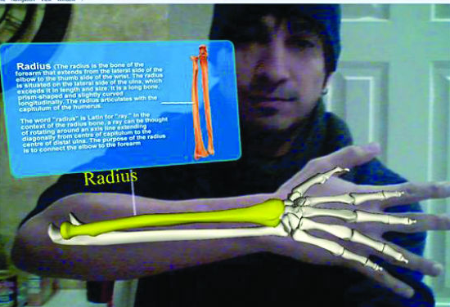

**Applications of Augmented Reality**

* Education

New possibilities for teaching and learning provided by AR have been increasingly recognized by educational researchers. The coexistence of virtual objects and real environments allows learners to visualize complex spatial relationships and abstract concepts , experience phenomena that is not possible in the real world , interact with two and three dimensional synthetic objects in the mixed reality , and develop important practices that can not be developed and enacted in other technology-enhanced learning environments . These educational benefits have made AR one of the key emerging technologies for education over the next five years .

* Military AR Uses

The Heads-Up Display (HUD) is the typical example of augmented reality when it comes to military applications of the technology. A transparent display is positioned directly in the fighter pilot's view. Data typically displayed to the pilot includes altitude, airspeed and the horizon line in addition to other critical data. The term "heads-up" name applies because the pilot doesn't have to look down at the aircraft's instrumentation to get the data he needs.

The Head-Mounted Display (HMD) is used by ground troops. Critical data such as enemy location can be presented to the soldier within their line of sight. This technology is also used for simulations for training purposes.

* Medical AR Uses

Medical students use AR technology to practice surgery in a controlled environment. Visualizations aid in explaining complex medical conditions to patients. Augmented reality can reduce the risk of an operation by giving the surgeon improved sensory perception. This technology can be combined with MRI or X-ray systems and bring everything into a single view for the surgeon.

Neurosurgery is at the forefront when it comes to surgical applications of augmented reality. The ability to image the brain in 3D on top of the patient's actual anatomy is powerful for the surgeon. Since the brain is somewhat fixed compared to other parts of the body, the registration of exact coordinates can be achieved. Concern still exists surrounding the movement of tissue during surgery. This can affect the exact positioning required for augmented reality to work.

* AR Apps for Navigation

Navigation applications are possibly the most natural fit of augmented reality with our everyday lives. Enhanced GPS systems use augmented reality to make it easier to get from point A to point B.

Using the smartphone's camera in combination with the GPS, users see the selected route over the live view of what is in front of the car.

* AR Gaming

With recent advances in computing power and technology, gaming applications in augmented reality are on the upswing. Head-worn systems are affordable now and computing power is more portable than ever. Before you can say "Pokemon Go," you can jump into an AR game that works with your mobile device, superimposing mythical creatures over your everyday landscape.

Popular Android and iOS AR apps include Ingress, SpecTrek, Temple Treasure Hunt, Ghost Snap AR, Zombies, Run! and AR Invaders.

**Application of Virtual Reality**

* Education

Education is area which has adopted virtual reality for teaching and learning situations. The advantage of this is that it enables large groups of students to interact with each other as well as within a three dimensional environment.

It is able to present complex data in an accessible way to students which is both fun and easy to learn. Plus these students can interact with the objects in that environment in order to discover more about them.For example, astronomy students can learn about the solar system and how it works by physical engagement with the objects within. They can move planets, see around stars and track the progress of a comet. This also enables them to see how abstract concepts work in a three dimensional environment which makes them easier to understand and retain.

* Health Care

Healthcare is one of the biggest adopters of virtual reality which encompasses surgery simulation, phobia treatment, robotic surgery and skills training.

One of the advantages of this technology is that it allows healthcare professionals to learn new skills as well as refreshing existing ones in a safe environment. Plus it allows this without causing any danger to the patients.

* Virtual Reality and Heritage

This refers to the use of virtual reality in museum and historical settings, e.g. visitor centres. These settings employ interaction as a means of communicating information to the general public in new and exciting ways.There has been a move away from the traditional type of experience associated with museums, galleries and visitor centres. Children are often difficult to attract to a museum or gallery as they tend to see this as a boring experience. But the use of interactive technologies such as virtual reality has changed that perception and opened up these spaces to a new audience.

* VR in the film industry

For the film industry rather than just being a spectator looking at the screen you could feel, see and hear what is going on around you. Other sensory tools could also be added such as smells and more intense touch such as soft, cold, hot to give you a more realistic experience. In the medical field it could enable training practitioners to perform surgeries and medical care before they are introduced to real patients. The possibilities for the future of virtual reality are endless.

# **3. Requirements and Analysis**

## **3.1. Functional and Nonfunctional Requirements**

* Hardware Functional Requirements
  + The device shall be wireless to make portable to use.
  + The device shall provide a minimum 85 degree field of vision in both directions (vertical and horizontal) where AR content can be displayed.
  + The device shall work in ambient temperatures up to 50 degree celsius
  + The device shall have an accelerometer, eye tracking and gyroscope that provides information to the software about gaze, and position.
* Software Functional Requirements
  + The application shall be able to display object after detecting the target.
  + The object displayed shall be stable and must not flicker.
  + The object shall be projected onto target object until target object is in vision of camera.
  + As soon as the target object is removed , the object shall be vanished.
  + The object shall be seen through Head mounted device.
* Nonfunctional Requirements
  + The application shall be easy to use.
  + The projected 3D object projected shall be aesthetically pleasing as well as of high quality.
  + The application should allow the use of Head mounted device.
  + As soon as the target is tracked , the object shall be displayed on it.

## **3.2. Constraints**

* Technological Constraints

1. Minimum API Level 16(Android Jellybean 4.1) required for smooth functioning of application.
2. Limited Computational Capability and limited Graphics Capability can affect the performance of the application.
3. Memory is a primary limitation on the amount of content that can be resident on a mobile device at any given moment

* Environmental Constraints

1. In all cases of augmented reality applications and devices that use computervision for tracking, it is essential that there is enough ambient light of the appropriate wavelength in the environment for the vision system to “see” the world
2. Harsh glare in sunny areas and shadows in sunny spaces can also be problematic, especially when using vision-based tracking
3. If the application generates sounds, it is necessary that the user is able to hear those sounds. Conversely, if the application is to be deployed in an area where extraneous sounds are not welcome, then it is important that the application not create unwanted sounds.

## **3.3. Hardware and Software Requirements**

1. Unity3D (Personal edition) (Version 2015 and above)
2. Vuforia
3. C#
4. Android SDK
5. VR Headset
6. Smartphone with Gyroscope and Magnetometer sensor

## **3.4. Analysis**

The traditional techniques used today by students are adding very little to the practical knowledge. They need to have a first hand experience. By integrating AR into the learning process, students find themselves more engaged with the topic and will be excited by the new ideas they are being exposed to. By fostering intellectual curiosity, retention levels are considerably higher and the costs in many situations can be much lower than traditional techniques. The applications for AR are definitely different than VR. Instead of a completely controlled and simulated world, AR provides you the opportunity to interact with the real world. Imagine a student reading through a book and seeing animated visualisations that make the content come alive. Discovery-based learning enables students to learn more about a real-life object such as at a museum or for new employees in a manufacturing plant.

For both AR and VR, the benefits over traditional approaches are much more than just better retention and a deeper understanding. Because the technology is also interactive, the technology can be used to test and evaluate understanding and reward users who master concepts before moving on. By integrating testing into the environment itself, the content can be highly tuned and even customised based on the learning style, background or even by how fast the student is learning. These technologies are able to see exactly where your eye is looking and even gauge your reaction while interacting with the environment. This allows for the extraction of behavioural based data, not just the basic pass marks we see with traditional learning. It is this type of revolution that our outdated methods needs and why we are seeing an inevitable migration towards these technologies.

**4. Proposed Design**

## **4.1. Architecture**

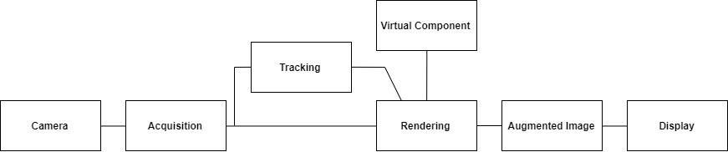

## **4.2. Detailed Design**

### **4.2.1 System Design**

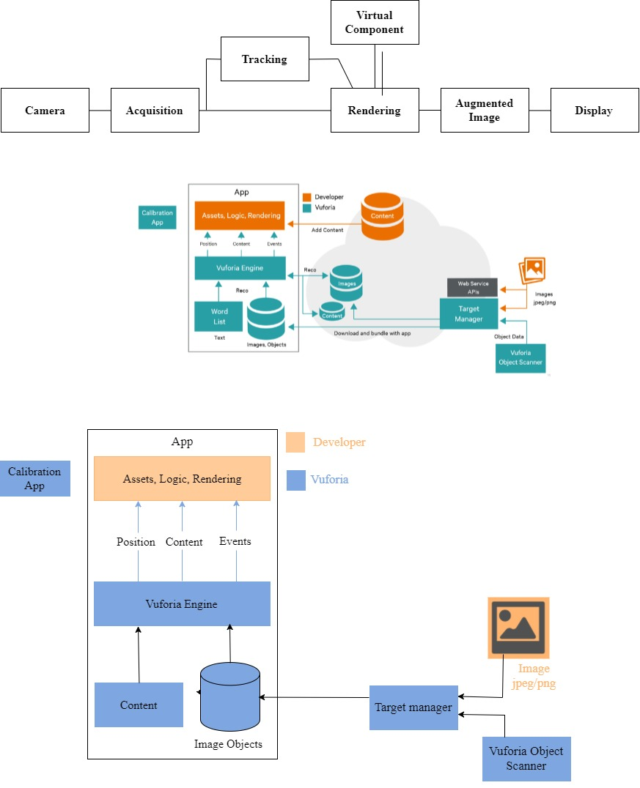

### **4.2.2 Flow Chart**

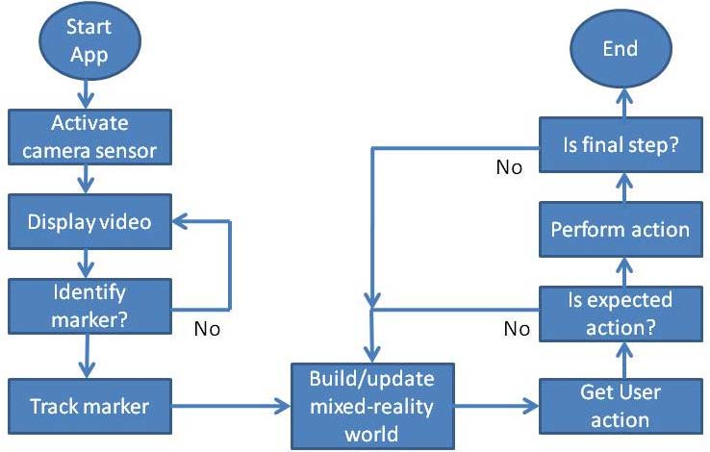

### **4.2.3 State Transition Diagram**

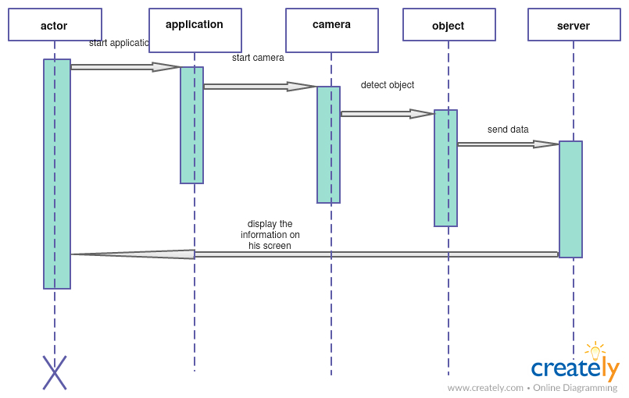

# 

# 

# 

# 

# 

# **5. Expected Results and Conclusion**

## **5.1. Expected Results**

Outcome of the project will be an android application “Exploration” using Recognition based AR. Exploration app will be a marker based augmented reality using Android OS. In this project, we aim to investigate and apply various innovative applications of Virtual and Augmented Reality on real life surroundings and enhance the skills of individuals and society in an interactive manner.

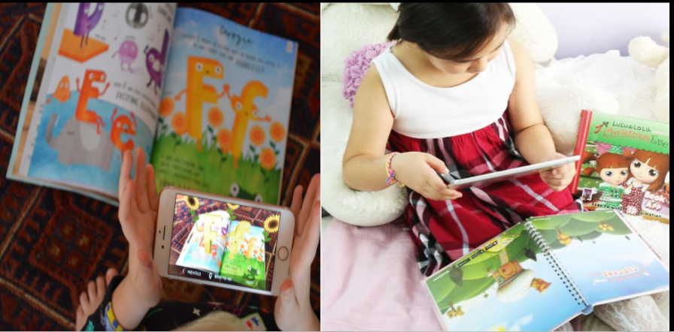

## **5.2. Conclusion**

We have proposed an AR application which uses marker based augmented reality for displaying object on a single piece of paper in the real world. The proposed application will be blended with VR such that the application shall be seen through head mounted device. This combination of augmented and virtual reality will provide real time immersive experience to the users.

## 

## **References**

1. “Recent Advances in Augmented Reality” published by Ronald Azuma(HRL Laboratories, LLC), Yohan Baillot(Naval Research Laboratory), Reinhold Behringer(Rockwell Science Center), Steven Feiner(Columbia University), Simon Julier(Naval Research Laboratory), Blair MacIntyre(Georgia Tech GVU).
2. “A Survey of Augmented Reality” published by Ronald T. Azuma (Hughes Research Laboratories)
3. “An Augmented Reality Interface to Contextual Information” published by Antti Ajanki, Mark Billinghurst, Hannes Gamper, Melih Kandemir, Samuel Kaski, Markus Koskela, Mikko Kurimo, Teemu Ruokolainen, Timo Tossavainen.
4. “Augmented Reality: Applications, Challenges and Future Trends” published by Mehdi Mekni (University of Minnesota, Crookston Campus), Andre Lemieux (TANYT, Quebec (QC), Canada)
5. “A review of using Augmented Reality in Education from 2011 to 2016” published by Smart Learning Institute, Beijing Normal University, Beijing, China and Departments of Educational Technology, Capital Normal University, Beijing, China

## 

## **Acknowledgment**

We are thankful to our college Vivekanand Education Society’s Institute of Technology for considering our project and extending help at all stages needed during our work of collecting information regarding the project.

It gives us immense pleasure to express our deep and sincere gratitude to Assistant Professor Mrs. Smita Jangale (Project Guide) for her kind help and valuable advice during the development of project synopsis and for her guidance and suggestions.

We are deeply indebted to Head of the Information Technology Department Dr.(Mrs.) Shalu Chopra and our Principal Dr. (Mrs.) J.M. Nair , for giving us this valuable opportunity to do this project.

We convey our deep sense of gratitude to all teaching and non-teaching staff for their constant encouragement, support and selfless help throughout the project work. It is great pleasure to acknowledge the help and suggestion, which we received from the Department of Information Technology.

We wish to express our profound thanks to all those who helped us in gathering information about the project. Our families too have provided moral support and encouragement at several times.